|  |  |
| --- | --- |
| EXP.NO: 01 |  |
| DATE: |  |

AIM:

ALGORITHM:

SOURCE CODE:

import cv2  
  
  
def main():  
 image = cv2.imread('C:\\Users\\CSE\\Desktop\\cat.jpg')  
 if image is None:  
 print("ERROR: could not find image")  
 return  
 res_image = cv2.resize(image, (500, 500))  
 cv2.imwrite("resized_image.jpg", res_image)  
 print("Resized image is saved")  
 cv2.imshow("Original image", image)  
 cv2.imshow("Resized image", res_image)  
 cv2.waitKey()  
 cv2.destroyAllWindows()  
  
  
if __name__ == "__main__":  
 main()

OUTPUT:

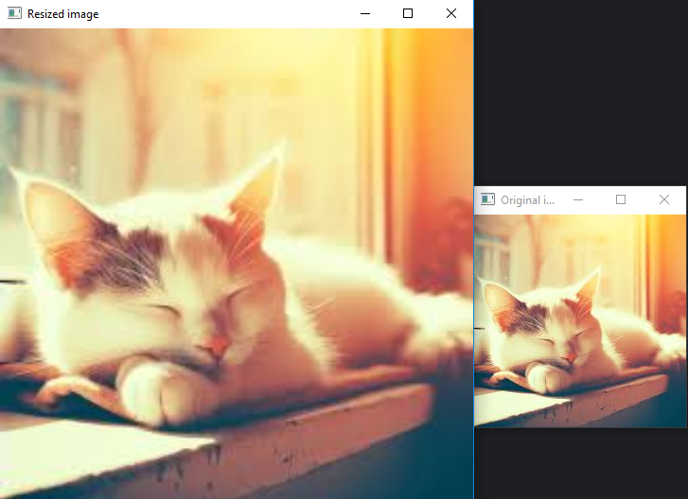

RESULT:

|  |  |
| --- | --- |
| EXP.NO: 02 |  |
| DATE: |  |

AIM:

ALGORITHM:

SOURCE CODE:

import cv2  
  
  
def main():  
 image = cv2.imread('C:\\Users\\CSE\\Desktop\\cat.jpg')  
 if image is None:  
 print("ERROR: could not find image")  
 return  
 gray_image = cv2.cvtColor(image, cv2.COLOR_BGR2GRAY)  
 hsv_image = cv2.cvtColor(image, cv2.COLOR_BGR2HSV)  
 cv2.imshow("Original image", image)  
 cv2.imshow("Gray image", gray_image)  
 cv2.imshow("HSV image", hsv_image)  
 cv2.waitKey()  
 cv2.destroyAllWindows()  
  
  
if __name__ == "__main__":  
 main()

OUTPUT:

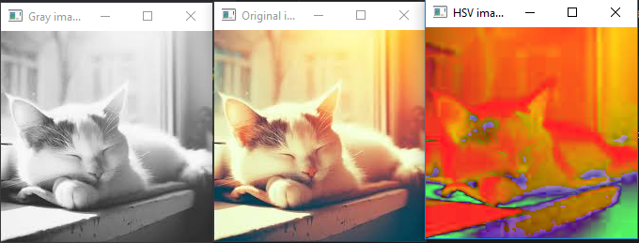

RESULT:

|  |  |
| --- | --- |
| EXP.NO: 03 |  |
| DATE: |  |

AIM:

ALGORITHM:

SOURCE CODE:

import cv2  
import numpy as np  
  
image = np.ones((500, 500, 3), dtype="uint8") * 255  
cv2.line(image, (50, 50), (450, 450), (0, 0, 255), 5)  
cv2.circle(image, (250, 250), 100, (0, 255, 0), 3)  
cv2.rectangle(image, (50, 400), (450, 450), (255, 0, 0), -1)  
cv2.rectangle(image, (100, 100), (400, 400), (0, 255, 255), 5)  
cv2.imshow("Image with Shapes", image)  
cv2.waitKey(0)  
cv2.destroyAllWindows()

OUTPUT:

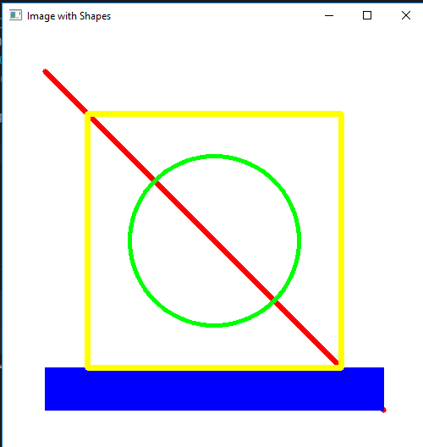

RESULT:

|  |  |
| --- | --- |
| EXP.NO: 04 |  |
| DATE: |  |

AIM:

ALGORITHM:

SOURCE CODE:

import cv2  
from PIL import Image  
  
# Load an image  
image = cv2.imread('C:\\Users\\CSE\\Desktop\\cat.jpg')  
  
# Print image properties  
print("Image Height:", image.shape[0]) # Height  
print("Image Width:", image.shape[1]) # Width  
print("Number of Channels:", image.shape[2]) # Channels (e.g., 3 for BGR, 1 for grayscale)  
print("Image Size (in Pixels):", image.size) # Total number of pixels  
print("Image Data Type:", image.dtype) # Data type of image (e.g., uint8)  
# Open an image using Pillow  
image = Image.open('C:\\Users\\CSE\\Desktop\\cat.jpg')  
  
# Get the format of the image (e.g., 'JPEG', 'PNG', etc.)  
print("Image Format:", image.format)

OUTPUT:

Image Height: 159

Image Width: 318

Number of Channels: 3

Image Size (in Pixels): 151686

Image Data Type: uint8

Image Format: JPEG

RESULT:

|  |  |
| --- | --- |
| EXP.NO: 05 |  |
| DATE: |  |

AIM:

ALGORITHM:

SOURCE CODE:

import cv2  
image = cv2.imread('cat.jpg')  
res_img = cv2.resize(image,(400,350))  
text = 'cat'  
position = (30, 50)  
font = cv2.FONT_HERSHEY_SIMPLEX  
font_scale = 1  
color = (255, 0, 0)  
thickness = 2  
cv2.putText(res_img, text, position, font, font_scale, color, thickness)  
cv2.imshow('Image with Text', res_img)  
cv2.waitKey(0)  
cv2.destroyAllWindows()

OUTPUT:

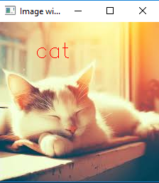

RESULT:

|  |  |
| --- | --- |
| EXP.NO: 06 |  |
| DATE: |  |

AIM:

ALGORITHM:

SOURCE CODE:

import cv2  
def read_and_display_images():  
 image_paths = [  
 'image.jpg',  
 'tank.bmp',  
 'sniper.png',  
 'bullet.tiff'  
 ]  
 for image_path in image_paths:  
 image = cv2.imread(image_path)  
 if image is None:  
 print(f"Error: Image '{image_path}' not found!")  
 continue  
 format_name = image_path.split('.')[-1].upper()  
 cv2.imshow(f"Image as {format_name}", image)  
 cv2.waitKey(0)  
 cv2.destroyAllWindows()  
read_and_display_images()

OUTPUT:

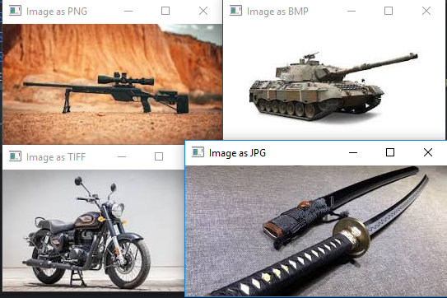

RESULT:

|  |  |
| --- | --- |
| EXP.NO: 07 |  |
| DATE: |  |

AIM:

ALGORITHM:

SOURCE CODE:

import cv2  
def read_and_display_image(image_path):  
 image = cv2.imread(image_path)  
 if image is None:  
 print("Error: Image not found!")  
 return  
 cv2.imshow("Original Image", image)  
 cv2.imwrite('output_image.png', image)  
 cv2.imwrite('output_image.bmp', image)  
 cv2.imwrite('output_image.tiff', image)  
 img_png = cv2.imread('output_image.png')  
 cv2.imshow("Image as PNG", img_png)  
 img_bmp = cv2.imread('output_image.bmp')  
 cv2.imshow("Image as BMP", img_bmp)  
 img_tiff = cv2.imread('output_image.tiff')  
 cv2.imshow("Image as TIFF", img_tiff)  
 cv2.waitKey(0)  
 cv2.destroyAllWindows()  
image_path = 'image.jpg'  
read_and_display_image(image_path)

OUTPUT:

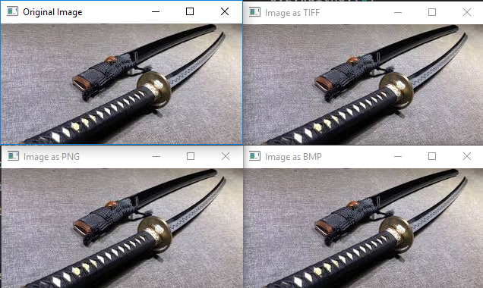

RESULT:

|  |  |
| --- | --- |
| EXP.NO: 08 |  |
| DATE: |  |

AIM:

ALGORITHM:

SOURCE CODE:

import cv2  
image = cv2.imread('bullet.tiff')  
rotated_image = cv2.rotate(image, cv2.ROTATE_90_CLOCKWISE)  
rotated_image_1 = cv2.rotate(image, cv2.ROTATE_90_COUNTERCLOCKWISE)  
rotated_image_2 = cv2.rotate(image, cv2.ROTATE_180)  
cv2.imshow("Original Image", image)  
cv2.imshow("90 Degree", rotated_image)  
cv2.imshow("-90 Degree",rotated_image_1)  
cv2.imshow("180 Degree",rotated_image_2)  
cv2.waitKey(0)  
cv2.destroyAllWindows()  
from PIL import Image  
image_path = "csk.jpg"  
img = Image.open(image_path)  
angle = 45  
rotated_img = img.rotate(angle, expand=True)  
rotated_img.show()  
rotated_img.save(f'rotated_{angle}_degrees.jpg')

OUTPUT:

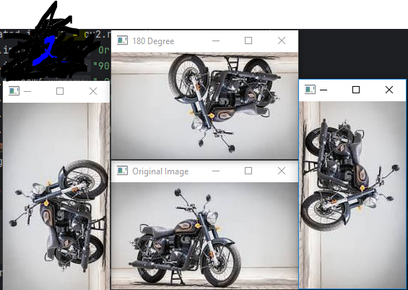

RESULT:

|  |  |
| --- | --- |
| EXP.NO: 09 |  |
| DATE: |  |

AIM:

ALGORITHM:

SOURCE CODE:

import cv2  
image = cv2.imread('tank.bmp')  
y_start, y_end = 10, 155  
x_start, x_end = 10, 155  
cropped_image = image[y_start:y_end, x_start:x_end]  
cv2.imshow('Original Image', image)  
cv2.imshow('Cropped Image', cropped_image)  
cv2.waitKey(0)  
cv2.destroyAllWindows()  
cv2.imwrite('cropped_image.jpg', cropped_image)

OUTPUT:

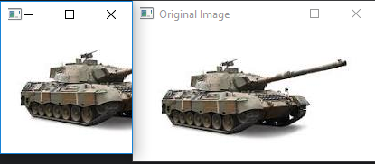

RESULT:

|  |  |
| --- | --- |
| EXP.NO: 10 |  |
| DATE: |  |

AIM:

ALGORITHM:

SOURCE CODE:

import cv2  
image = cv2.imread('image.jpg')  
flipped_horizontally = cv2.flip(image, 1)

flipped_vertically = cv2.flip(image, 0)

flipped_both = cv2.flip(image, -1)

cv2.imshow('Original Image', image)

cv2.imshow('Flipped Horizontally', flipped_horizontally)

cv2.imshow('Flipped Vertically', flipped_vertically)

cv2.imshow('Flipped Both', flipped_both)  
cv2.waitKey(0)  
cv2.destroyAllWindows()

OUTPUT:

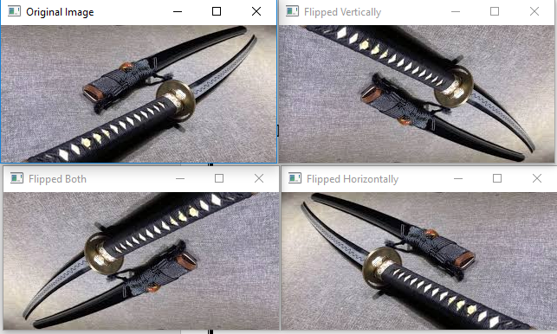

RESULT:

|  |  |
| --- | --- |
| EXP.NO: 11 |  |
| DATE: |  |

AIM:

ALGORITHM:

SOURCE CODE:

import cv2  
image = cv2.imread('sniper.png')  
cv2.imshow('Original Image', image)  
gaussian_blur = cv2.GaussianBlur(image, (5, 5), 0)  
cv2.imshow('Gaussian Blur', gaussian_blur)  
median_blur = cv2.medianBlur(image, 5) # 5x5 kernel  
cv2.imshow('Median Blur', median_blur)  
bilateral_blur = cv2.bilateralFilter(image, 9, 75, 75)   
cv2.imshow('Bilateral Filter', bilateral_blur)  
cv2.waitKey(0)  
cv2.destroyAllWindows()

OUTPUT:

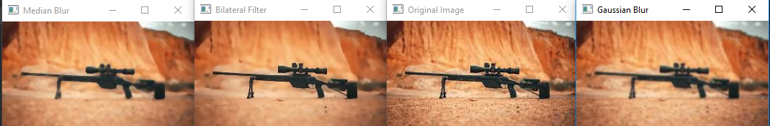

RESULT: